Executing with Swagger.

Api Page.

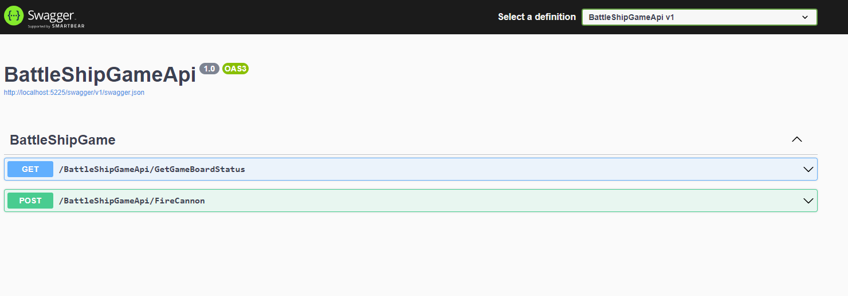

Result of the game board status Get method.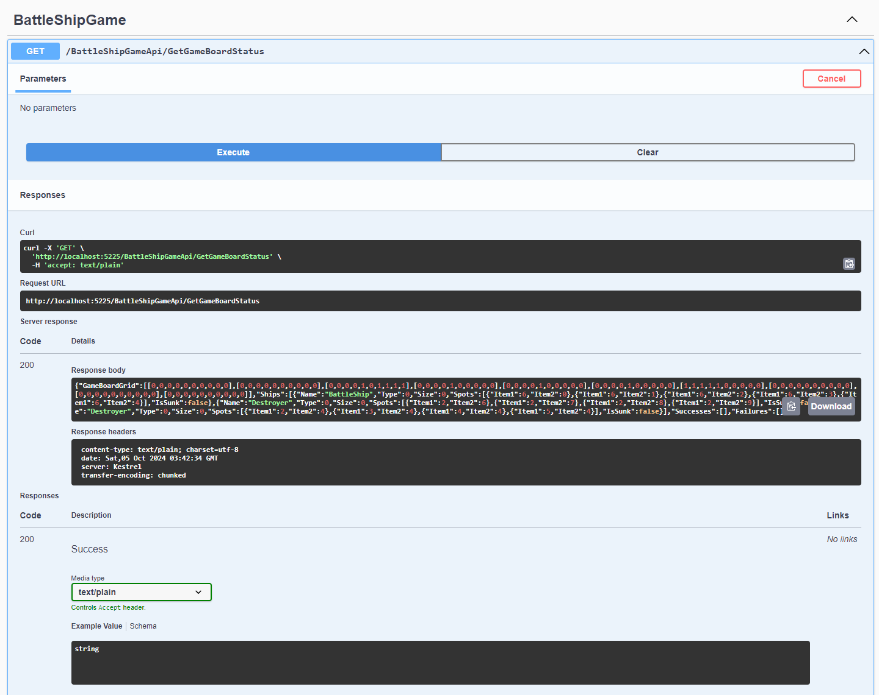

Fire cannon method – Missed fire.

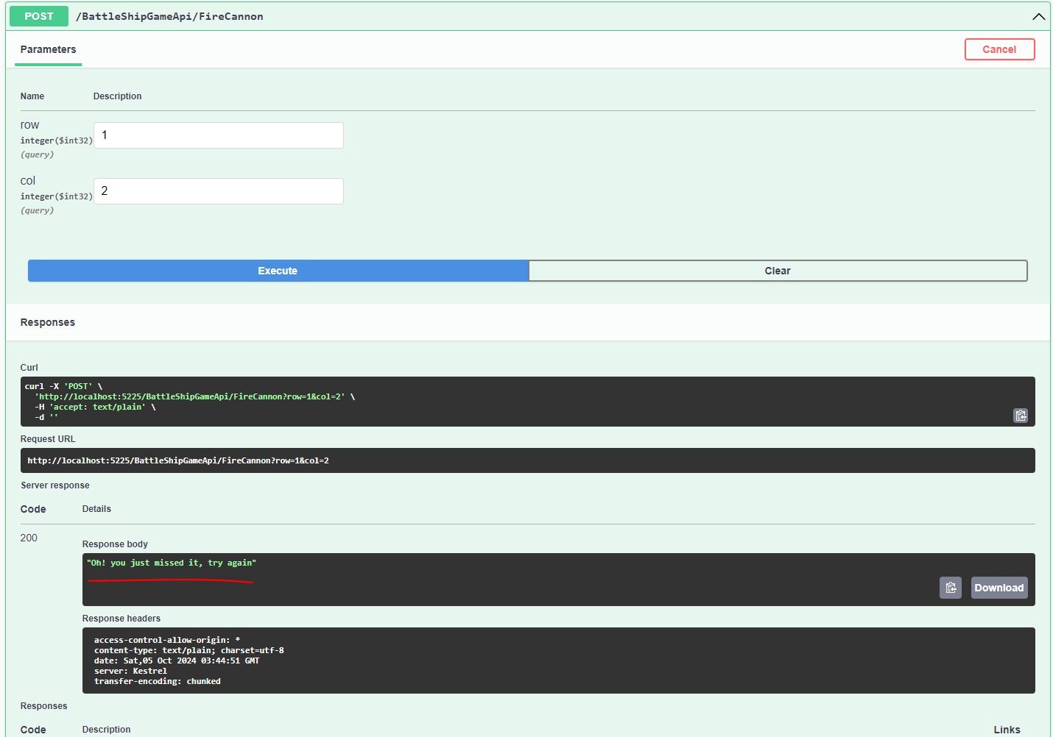

Fire cannon method – Successful fire.

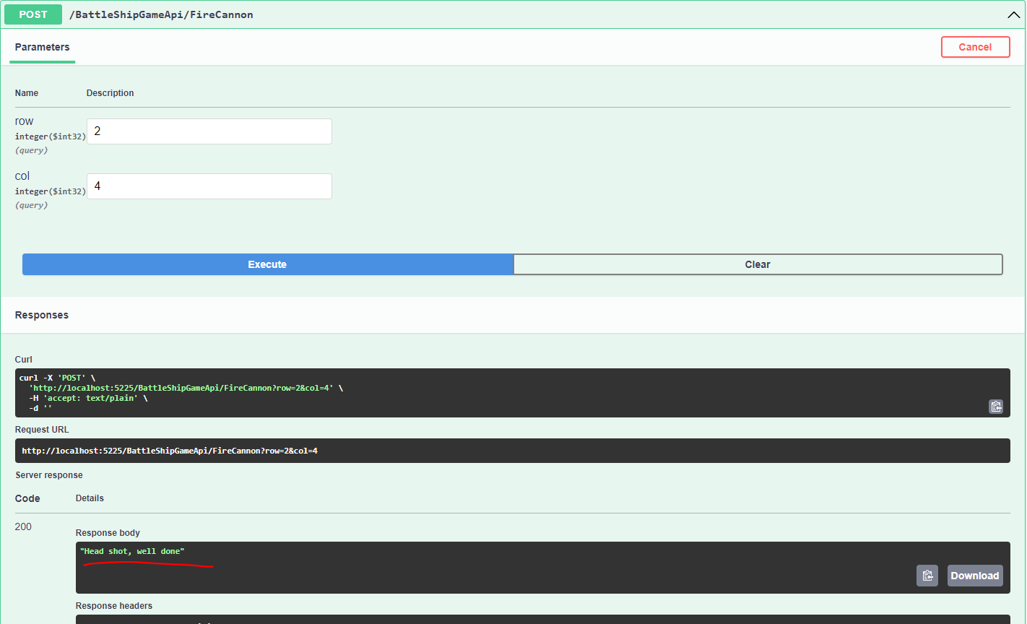

Fire cannon method – Already fired spot.

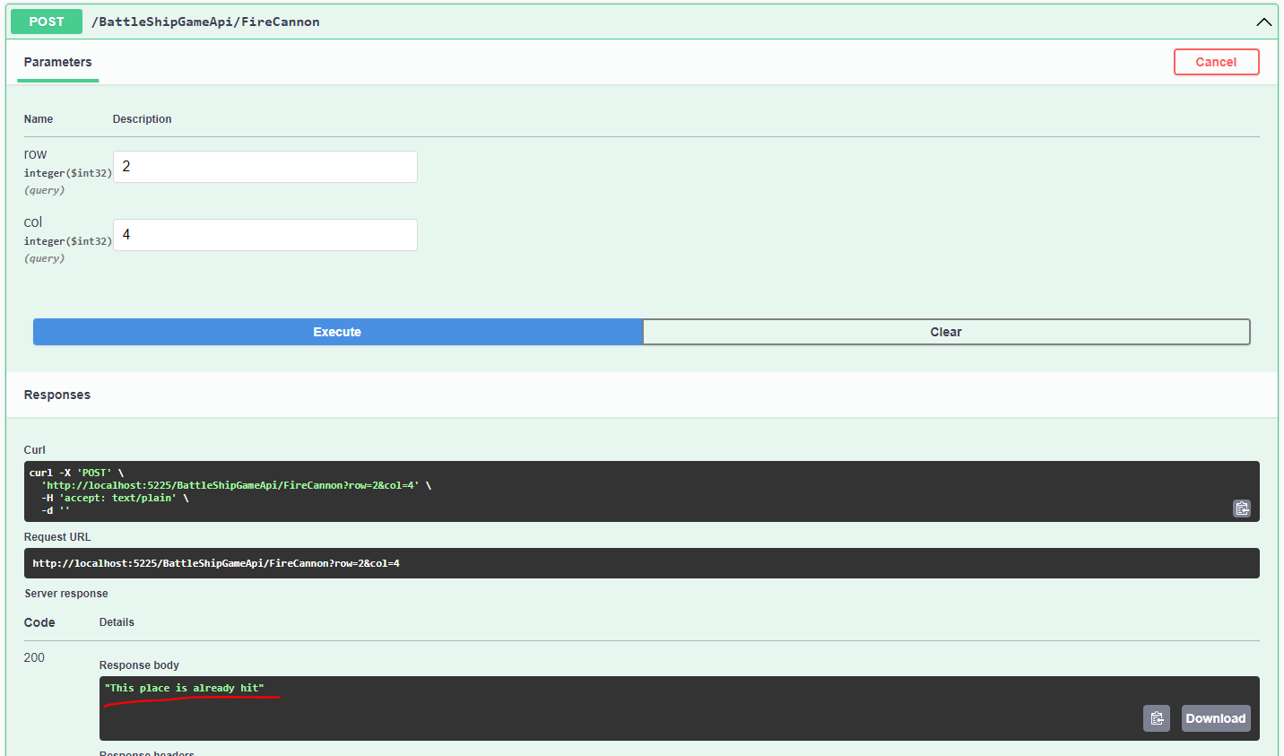

Fire cannon method – Sunk Ship.

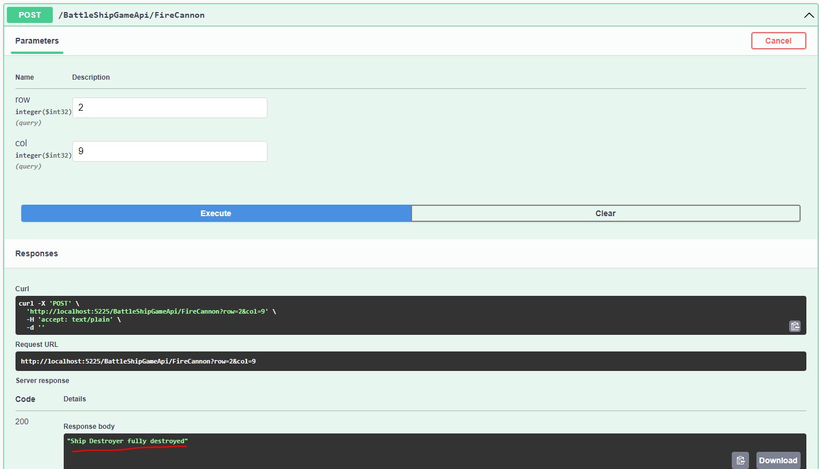

Fire cannon method – Invalid hit

